**DN 4.0 WEEK 8 MANDATORY PROBLEMS**

**MODULE 10: GIT**

1. **SETTING UP GITBASH**

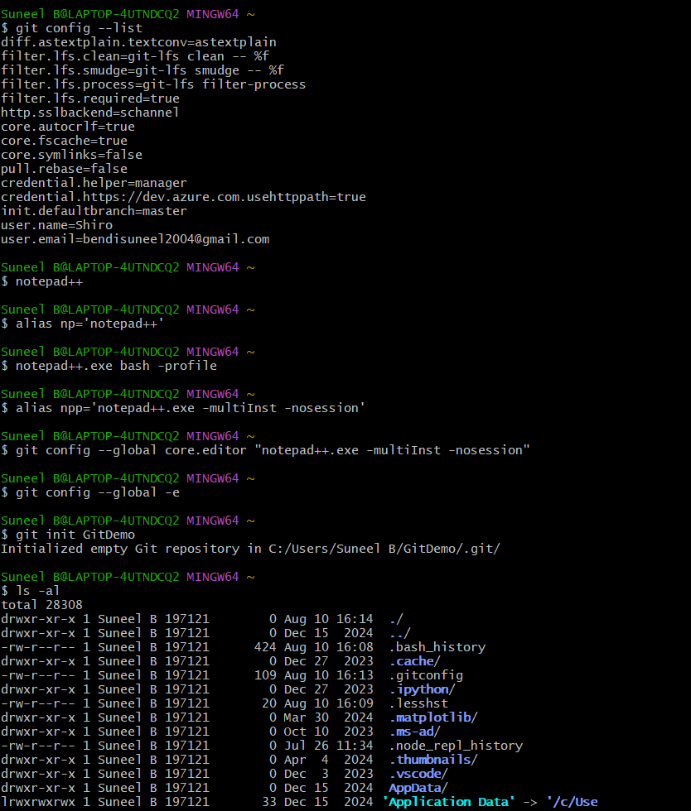

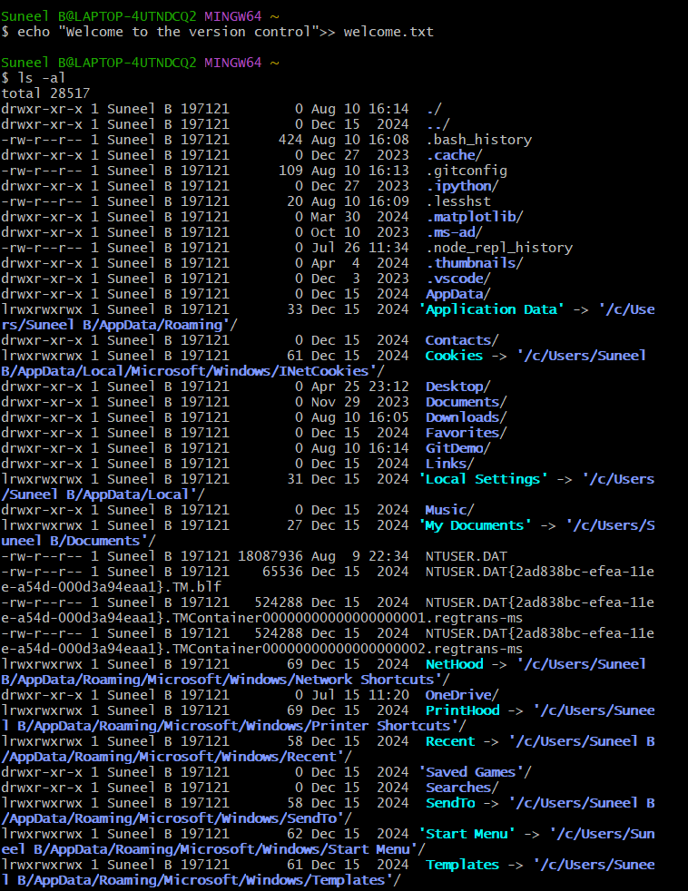

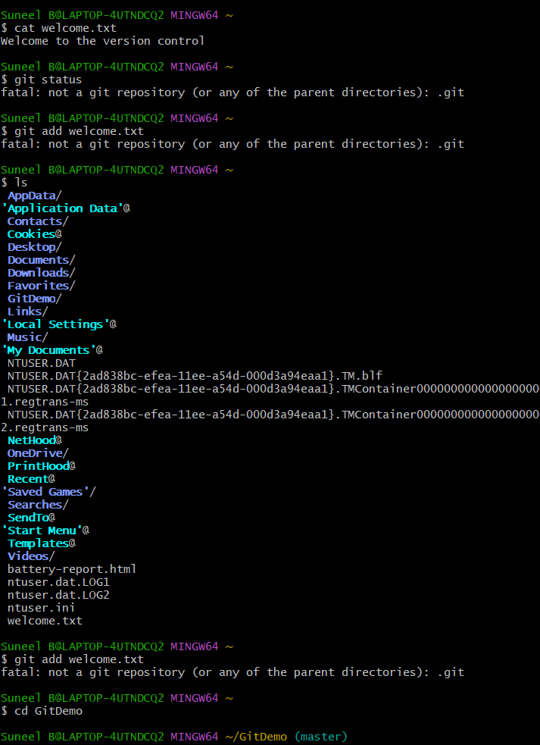

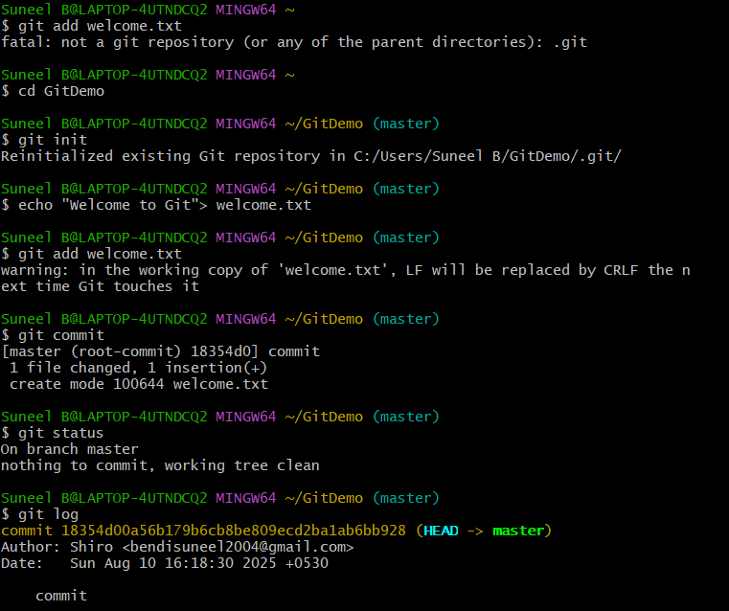

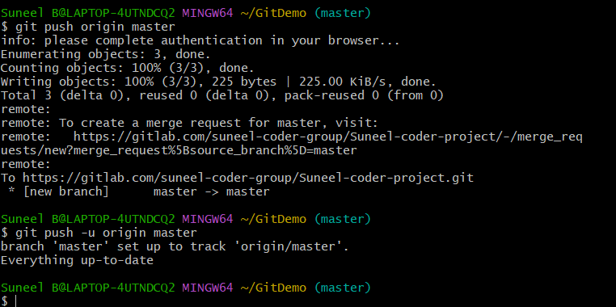

1. **OBJECTIVES:**
2. **What is .gitignore**

.gitignore is a special file in you Git repository where you list files and folders that GIT should not track.

1. **Explain how to ignore unwanted files using git ignore**

Git doesn’t automatically ignore files uncles you specify them in a

.gitignore file in the root of your repository

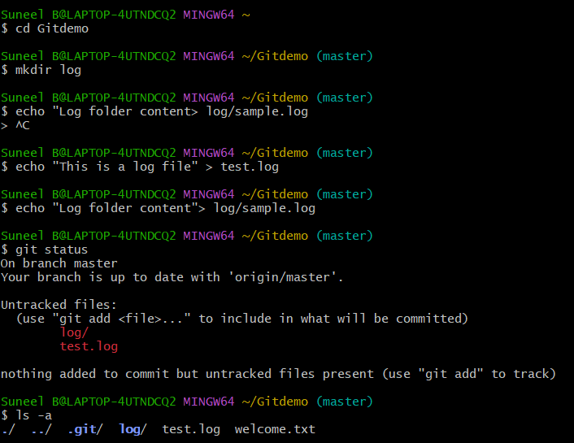

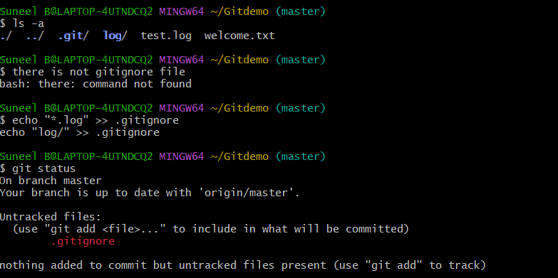

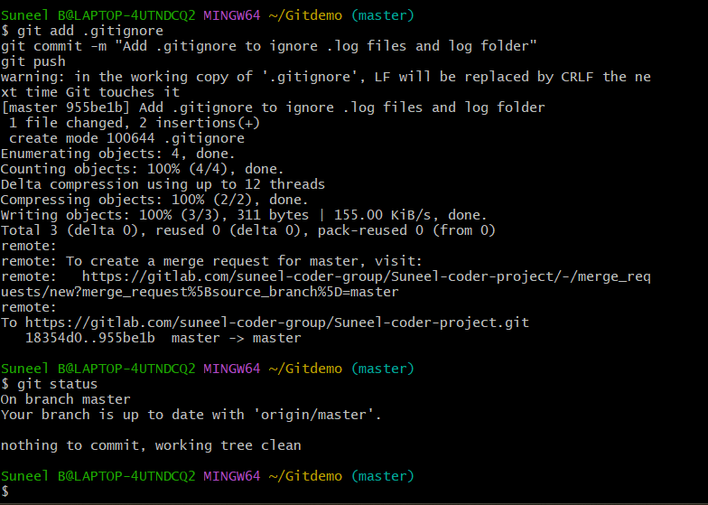

1. **OBJECTIVES:**

**Branching**

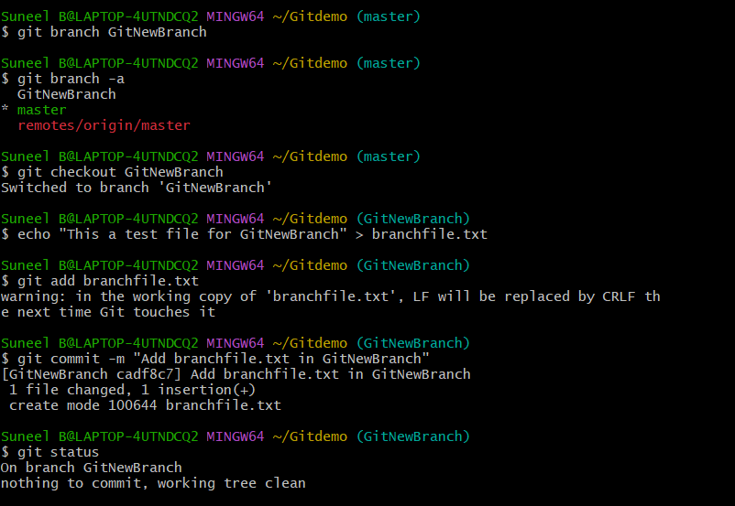

**Merging**

git difftool master GitNewBranch opens a graphical tool to compare differences

shows the master version on one side and GitNewBranch version on the other side

Benefits over CLI diff are side by side view

Git diff master GitNewBranch shows a text based changes between two branches

Compares the master branch to GitNewBranch line by line

Good for quick terminal check

Limitations are no visual layout so big changes will be harder

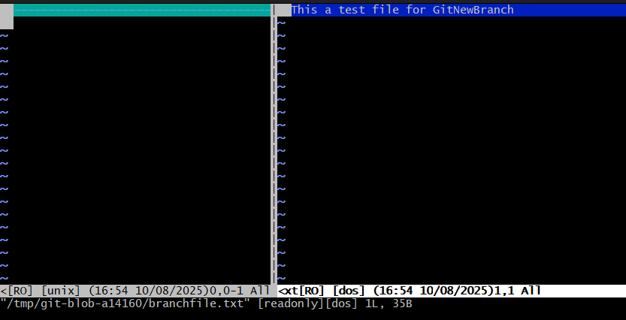



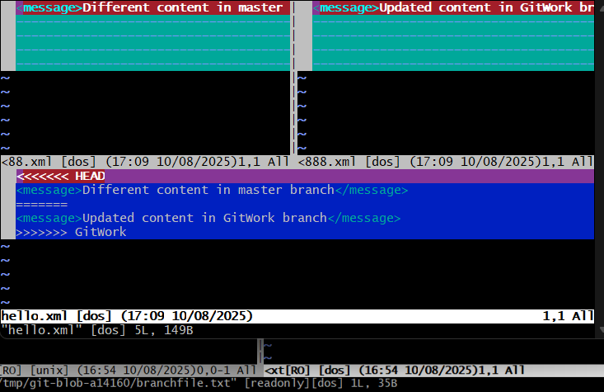

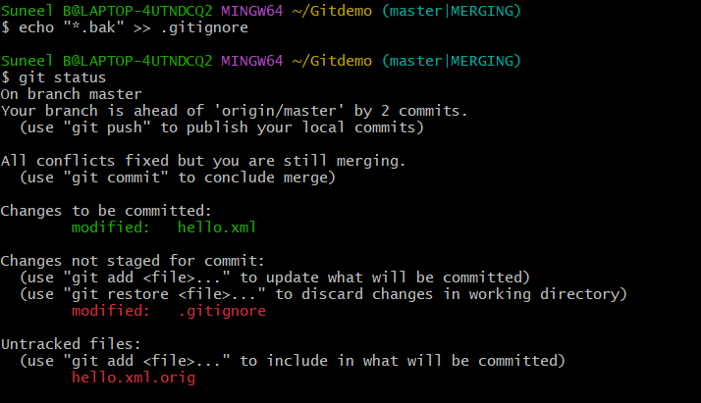

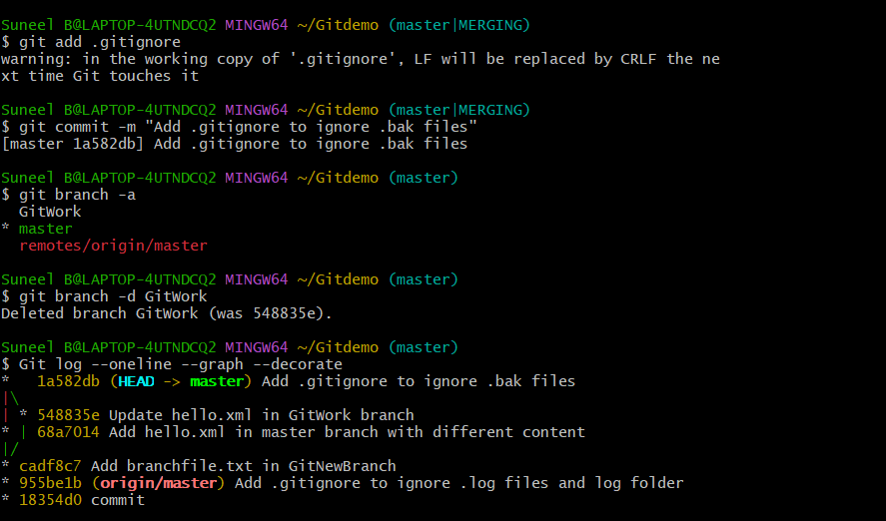

1. **Continuation of 2nd problem**

